

|  |  |
| --- | --- |
| **No.** | **List of Lab Experiments** |
| **1** | Implementation of Basic Gates and Universal Gates. |
| **2** | Implementation of Half Adder using  basic gates. |
| **3** | Implementation of Half Subtractor using basic gates. |
| **4** | Simplify equation and implement the simplified ckt. |
| **5** | Implementation of Binary to Excess-3 code conversion for 4 variable I/P. |
| **6** | Implementation of binary Parallel Adder using IC 74283. |
| **7** | Design Full Adder using Decoder |
| **8** | Implementation of boolean Functions using MUX. |
| **9** | Implement J-K F/F using NAND gate. |

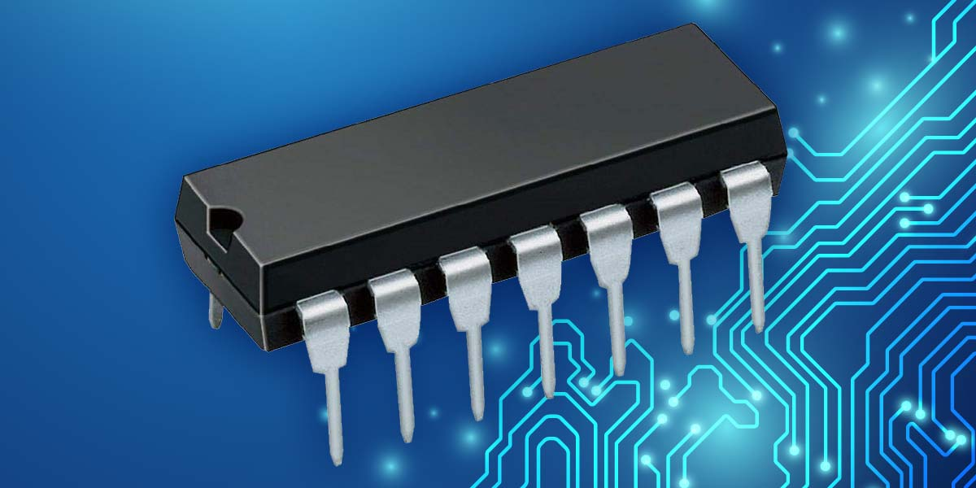

Date of Submission: 12.01.2020

**Course Code:** CSE 206

**Course Title:** Digital logic design Lab

**Submitted to:**

Name: Sohel Rana

Lecturer

Department of CSE

at Bangladesh University of Business and Technology.

**Submitted by:**

Name: Syeda Nowshin Ibnat

ID: 17183103020

Intake: 39 Section: 1

Program: B.Sc. in CSE

Semester: Fall 19-20